## Entities

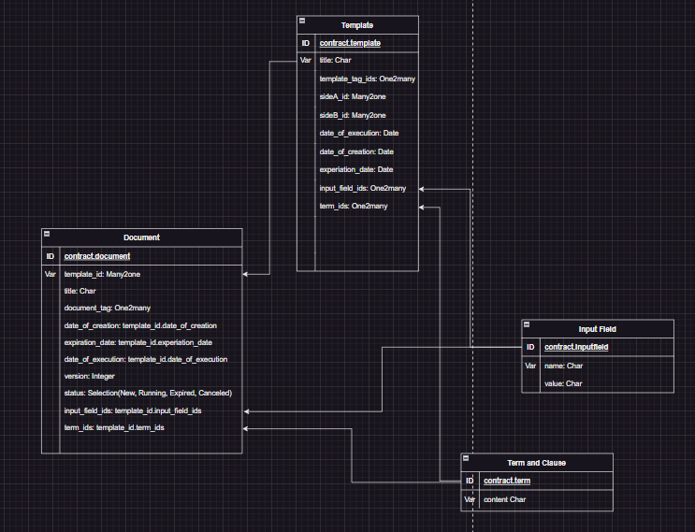

## Process Analysis

1. Template Setup
   * Create PDF templates with fixed and editable clauses and input fields (clauses can use values from input fields)
   * Store templates in the Documents module
2. Contract Creation
   * User selects a template from the dashboard
   * System auto-populates customer and company information
   * User inputs service details, contract value, and some other input fields in the template (User can add more input fields as unique to the document)
   * User edits non-fixed clauses as needed
3. Contract Review
   * User reviews the completed contract
   * System generates a PDF version of the contract
4. Signature Request
   * User initiates signature request from the contract view
   * System generates unique signature links for both parties
   * System sends signature requests via email and odoo
5. Contract Signing
   * Parties receive signature links
   * Parties review and sign the contract electronically
   * System tracks and updates signature status
6. Contract Storage
   * Signed contract is automatically stored in the Documents module (if able to pay for charged Odoo version)
   * Contract status is updated to "Signed"
7. Contract Management
   * User can view contracts through the Odoo account
   * Contract Documents and Contract Templates are listed with tags and filtering
   * System provides notifications for contract expiration or renewal dates